Project Development Phase

Performance Testing
Date: | 14 February 2026
Team ID: | LTVIP2026TMIDS71508
Project Name: | Calculating Family Expenses Using ServiceNow
Maximum Marks:
Model Performance Testing
S.No | Parameter | Values | Screenshot
1 | Application Summary | Expense data stored successfully.  Automatic calculation using business rules works correctly.  Expense summaries update in real time. | 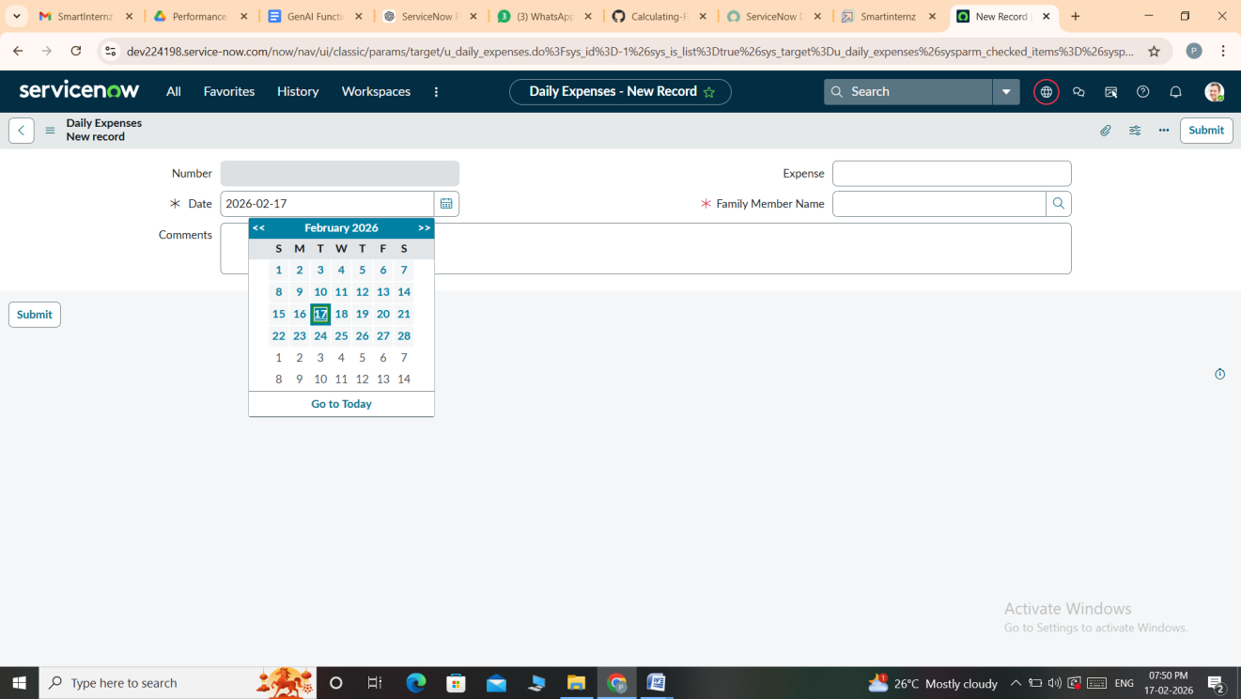
2 | Accuracy | Daily expense calculations verified.  Monthly summaries match expected totals.  System calculations are accurate. | 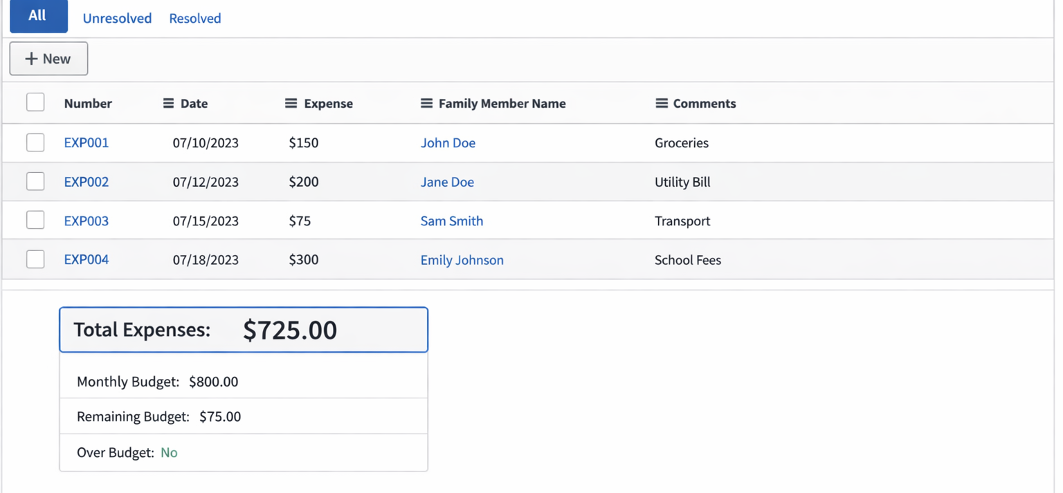
3 | Automation Result | Family expense totals automatically update when daily expenses are added or modified. | 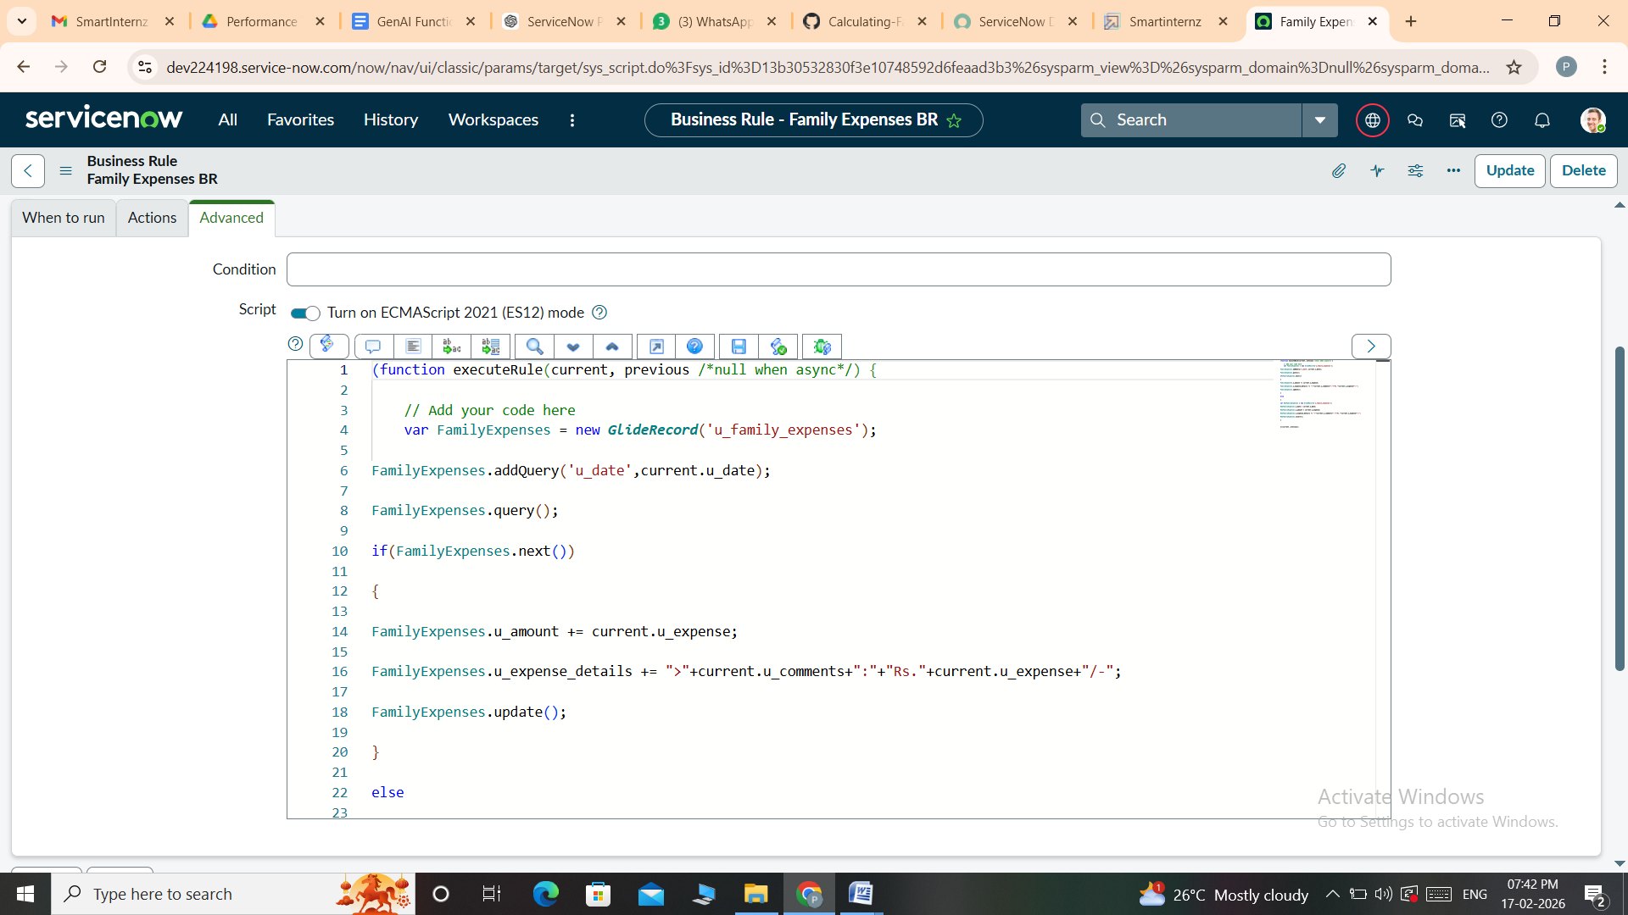
Conclusion: The application performs correctly with accurate expense recording, automatic calculations, and report generation.

